**Model One**

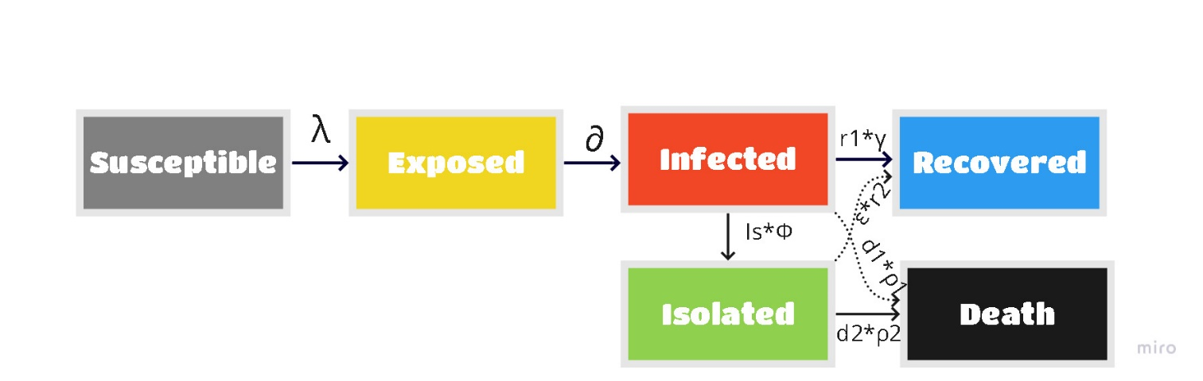

**Model Two**

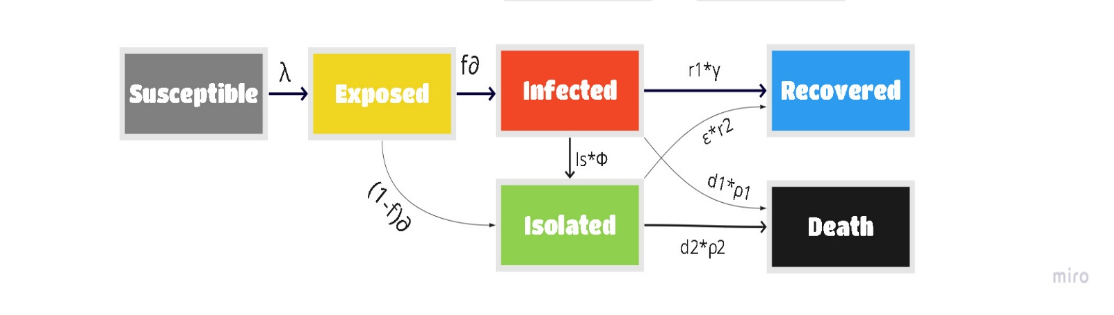

**Model Three**

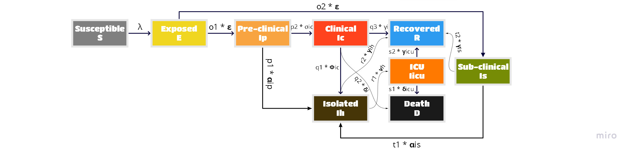

The differential compartment formulas are presented in the implementation (code).

Model One, force of infection: $λ=\frac{β*SD* \left(1-εmcm\right)I}{N}$ Assuming infection is only due to the infected compartment. Social distancing intervention actions will have an effect on transmission rate ($β$)

Model Two, force of infection: $λ=\frac{β *SD* \left(1-εmcm\right)*(I+ η* Iiso)}{N}$ Assuming infection is due to the infected but not isolated, and infected and isolated individuals. In addition, $η$ is Relative Infectiousness of the Hospitalized. SD (Social distancing) proportion kept at one, and its effect implemented through $β$.

Model Three, force of infection: $λ=\frac{β *SD* \left(1-εmcm\right)*(ηc* Ic+ ηh* Ih + ηp* Ip + ηs* Is)}{N}$ Assuming infection is due to the infected but not isolated, infected and isolated, pre-clinical and sub-clinical individuals. $ηh$ is Relative Infectiousness of the Hospitalized, $ηc$ is relative Infectiousness of the clinical individuals and $ηp$ is Relative Infectiousness of the pre-clinical individuals. SD (Social distancing) proportion kept at one, and its effect implemented through $β$.

Steps of installing .ipynp

1. Register or Login to colab.research.google.com
2. Import .ipynp file
3. Run each cell separately
4. You can adjust parameter values as you want to generate different outputs